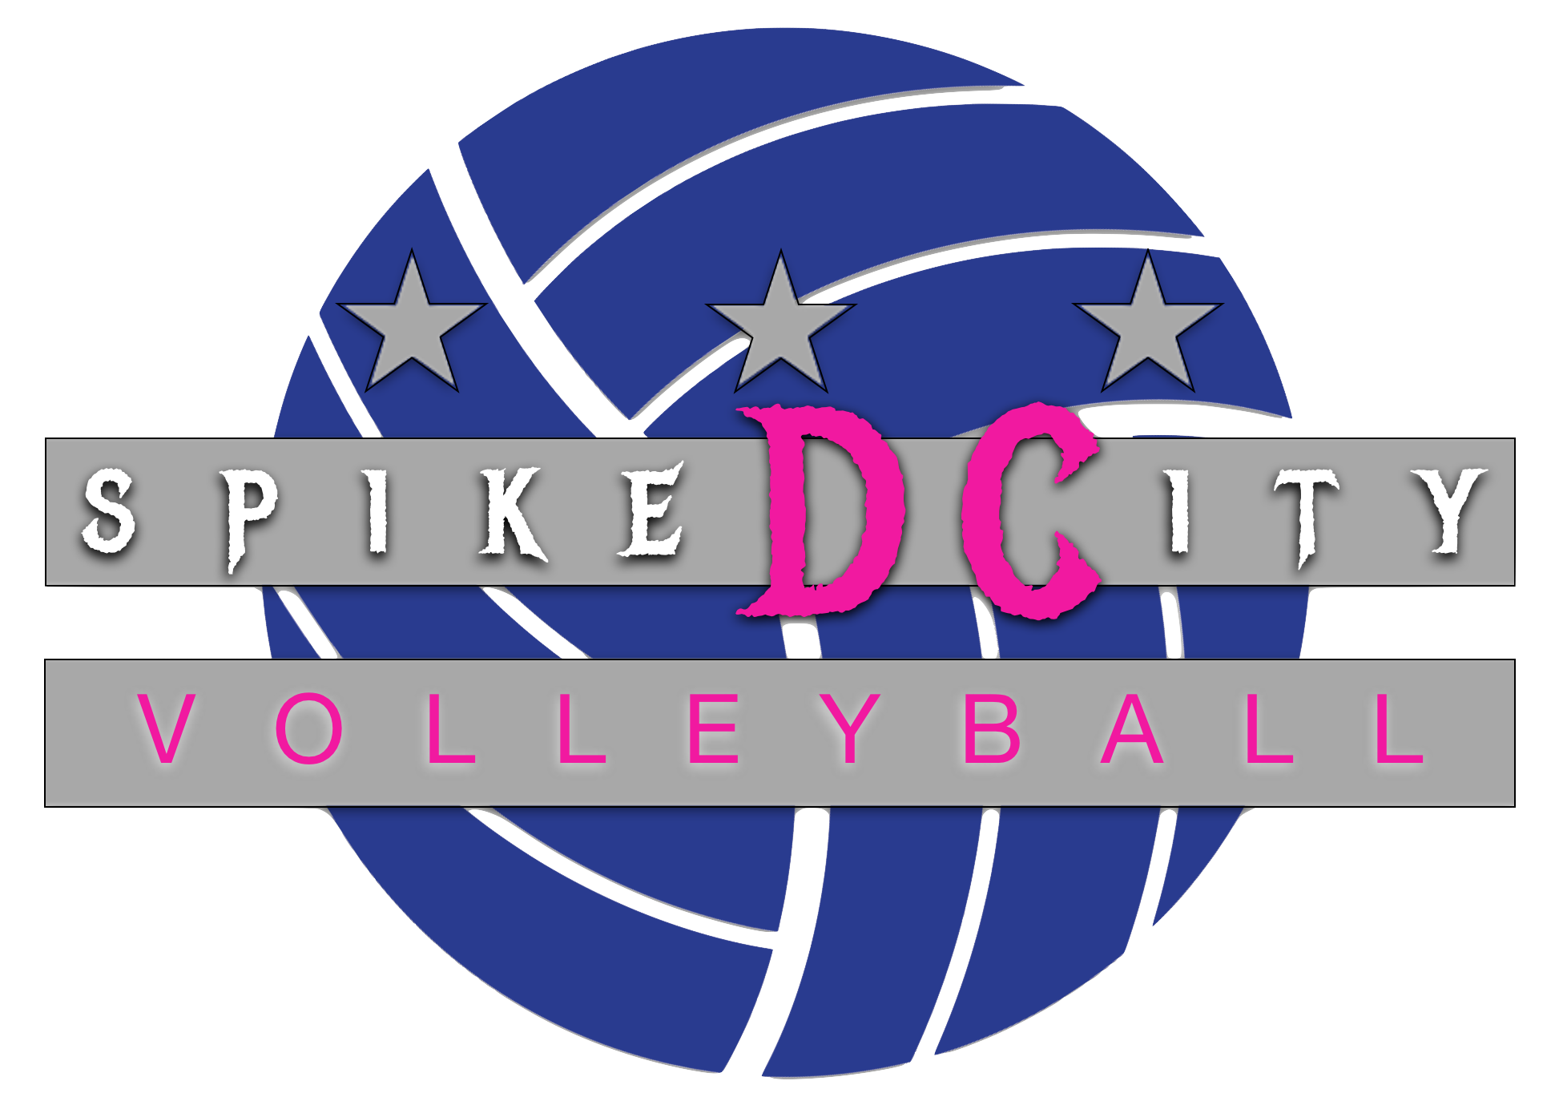
2026 - 2027 Player/Parent Contract

Player’s Name
Parent’s Name
Player Team (check one) | - Developmental  - 13U/14U  - 13U/14U Practice Player  - 15U  - 16U Practice Player  - 17U  - 17U Practice Player

Each Player and Parent must read this Player/Parent Contract and initial and sign where indicated to acknowledge their understanding and acceptance of and agreement to abide by terms of this Player/Parent Contract.

Parent Initials | Player Initials
 |  | I accept a position as a member of Spiked City DC VC (SCDCVC)
 |  | I understand and accept the importance of practice and game attendance. I will make every reasonable effort to attend all scheduled practices and tournaments, I will submit my monthly conflicts to my coach and will notify my coach in advance if something arises and I cannot attend a practice or tournament.
 |  | I understand and accept that decisions about playing time are at the sole discretion of the coaching staff. The SCDCVC’s philosophy is that you are purchasing training time. This training occurs primarily in practice and secondarily in tournaments. Playing time is not subject to negotiation. Therefore, I understand that the SCDCVC season is to help with training and development. I also understand that playing time is not subject to challenge by players or parents.
 |  | I understand and accept that an atmosphere of good sportsmanship be maintained at all practices and games.
 |  | I understand and agree that the following behaviors will not be tolerated at any time and are grounds for immediate suspension and/or expulsion from the Spiked City DC Volleyball Club: Use of alcohol, tobacco or drug use of any kind, missing curfew if/when at traveling competitions, vandalizing any property or hotel room, verbal or physical assault on a coach, opponent or referee.
 |  | I understand and agree to my financial obligations and payment schedule.
 |  | I understand and agree that as a result of failure to pay the club fees or any other breach or violation of the terms of the Player/Parent Contract that this Contract can be terminated. Any other action by a Player or Parent with SCDCVC, that the club’s administrators and/or coaches may believe to be injurious to SCDCVC, its administrators and/or coaches, may be cause for termination at any time by SCDCVC. I further understand and agree that if this Player/Parent Contract is terminated by SCDCVC, I will be obligated to pay SCDCVC the entire Club Fee amount that remains to be paid, immediately upon demand.
 |  | I understand that there is zero tolerance for bullying. “Bullying” of teammates, coaches, or parents will result in immediate dismissal from the club.
 |  | I understand that as a member of a team it is my responsibility to cheer for my team and permeate positivity. I will not berate my coaches, teammates or chaperones or display any other unsportsmanlike conduct.
 |  | I will complete the necessary online requirements for the USAV Scorekeeping and referee clinics and perform the duties required to obtain or renew certification as a referee and scorekeeper before the first tournament. I understand that failure to do so may result in a lack of playing time. I acknowledge that I have read all USAV policies and will abide by those rules.
 |  | I acknowledge that I am not allowed to leave a playing site during a tournament. At the coach’s discretion, I may be allowed to depart temporarily with a parent/guardian. I understand that if I leave a tournament without a coach’s permission I may be suspended for the remainder of the tournament.
 |  | I acknowledge that I am responsible for fulfilling all team work assignments during tournaments and not permitted to leave until assignments have been completed. Failure to fulfill work team responsibilities may result in suspension from the team.
 |  | I understand that I may quit the club at any time, however, it does not release me from my financial responsibilities regarding full payment of club fees.
 |  | I understand and agree to my financial obligations and payment schedule and acknowledge that if my payment is not current, I will not be permitted to participate in any SCDC activities until outstanding fees are current.
 |  | I understand that I must comply with all club, region, state and federal requirements related to COVID-19 safety and that failure to do so may result in my dismissal from the club.
 |  | I understand that if I engage in any inappropriate or prohibited behavior as assessed by CHRVA standards during any CHRVA sanctioned event, I may be assessed a fine of up to $500 and prevented from any further club participation
Parent Initials | Player Initials
Date Signed

